

SRC Week 1 Student Exercises
Introduction to Data Analytics
Course | Excel and Power BI in 10 Weeks
Week | Week 1 Introduction to Data Analytics
Designed by | Philip McClelland
For | Students

This workbook takes you through one complete, fictional Campus Cafe task. You will frame a useful question, calculate sales in Excel, and turn the same table into an interactive Power BI report. Work at your own pace, pause after each checkpoint, and save often.

Start here
□ Download SRC_Week_1_v1.2_Campus_Cafe_Student.xlsx from Teams or the Week 1 course page.
□ Check that Microsoft Excel and Power BI Desktop open on your computer.
□ Create a Week 1 folder and keep this PDF open beside the software, or print it.
□ Use the interactive lesson for narration and demonstrations; this PDF is your task sheet.

Your finish line
- A completed Excel workbook with 50 correct Sales Value formulas.
- A Power BI report with a campus column chart, total-sales card, and category slicer.
- A short conclusion that includes a finding, an action, a limitation, and one useful extra field.
Working safely The Campus Cafe dataset is fictional. Do not add real student, customer, or staff details.
Learning from mistakes If a check fails, use the message to find one next fix. You do not need to restart the whole task.

Activity 1 Understand the question
SRC runs a fictional cafe at five campuses: Armagh, Banbridge, Lurgan, Newry, and Portadown. The cafe supervisor wants a quick view of sales from 1 to 10 September 2026 to help plan stock and staffing.

Use the five context questions
Question | Your answer
What do we need to understand?
Why does it matter?
Who will use the result?
Where was the data collected?
When does the data cover?

Choose the analysis type
The report will summarise sales that have already happened. Circle one: descriptive / diagnostic / predictive / prescriptive
In one sentence, explain why your choice fits the task

Pause and check
□ Your answers describe a decision, not just a chart.
□ Who means the person using the result; it does not mean collecting personal data.
□ You can explain the difference between what happened and why it happened.

Activity 2 Recognise the data
Choose categorical, numerical, or date for each field. Add nominal, ordinal, discrete, or continuous where it helps. A number is not automatically numerical data: sometimes it is a label or an ordered category.
Field | Main type | More detail
Transaction ID
Date
Campus
Product Category
Units Sold
Unit Price
Payment Method
Customer Rating 1 to 5
Sales Value

Quick check
A. Customer Rating uses the values 1 to 5. Why is ordinal a better description than a measured amount?
Write one sentence: ________________________________________________________________
B. Which field uniquely identifies a row but should not be added or averaged?
Answer: ___________________________________________________________________________

What this protects you from
Correct field roles prevent misleading totals and charts. For example, adding transaction identifiers would produce a meaningless result, while summing Sales Value answers a real business question.

Activity 3 Prepare the data in Excel
Open SRC_Week_1_v1.2_Campus_Cafe_Student.xlsx and select Sales Data. The yellow Sales Value column is intentionally incomplete.
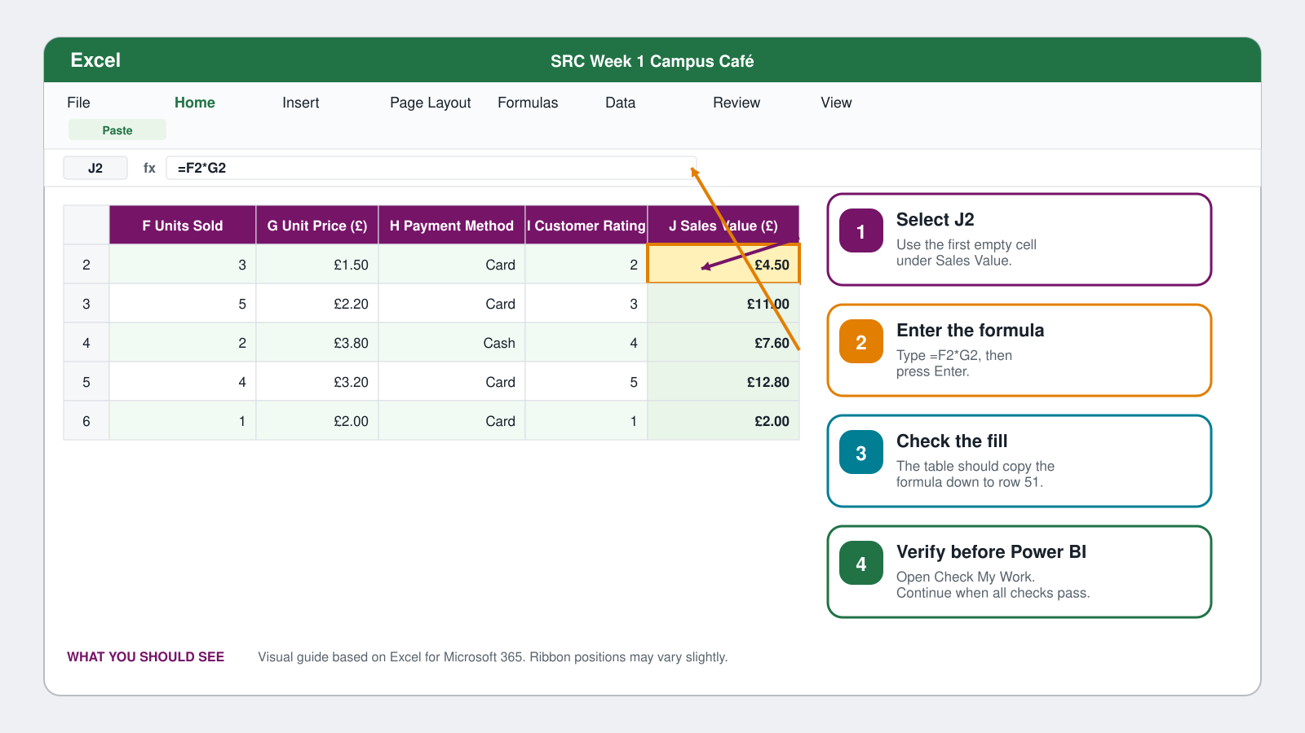
What you should see in Excel. Button positions may vary slightly by version.
1 Create Sales Value
Click J2, enter =F2*G2, and press Enter. If the table does not fill automatically, copy the formula down to J51.
2 Format and inspect
Apply Pound Sterling with two decimal places to Unit Price and Sales Value. Use a clear date format. Sort Sales Value largest to smallest, then clear the sort if you wish.
3 Filter and highlight
Filter Campus to Newry, then clear the filter so all 50 rows return. Highlight ratings of 4 or 5 with simple conditional formatting.
4 Calculate a total
Use =SUM(J2:J51) in an empty cell. Record the result below.
Largest transaction ID and value

Total Sales Value

Excel checkpoint Check My Work
Open the Check My Work sheet before moving to Power BI. It checks your row count, rating values, Sales Value coverage, and total. Do not edit the checker cells.
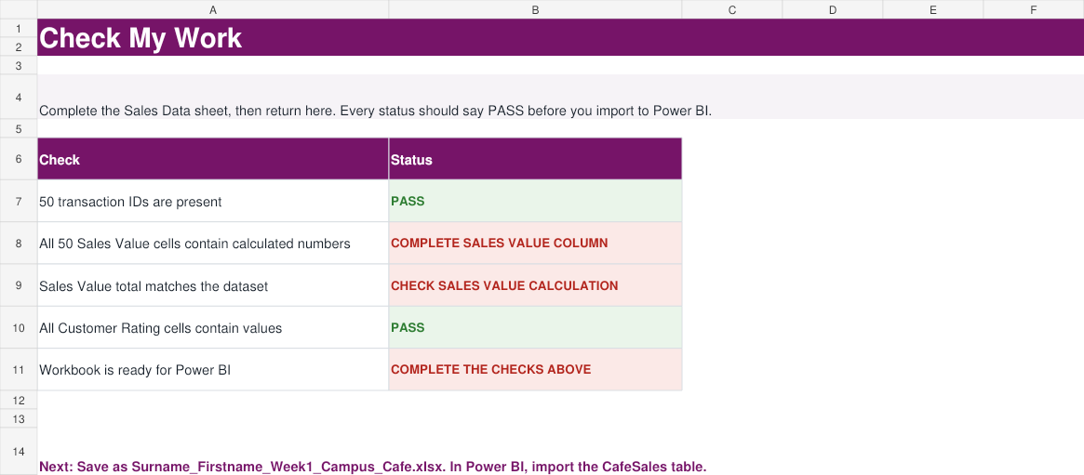
Before the formula is complete, the last two checks show Fix this. When all four show PASS, continue.
□ All four status cells show PASS.
□ The total is £351.60.
□ All filters are cleared and 50 rows are visible.
□ Save a working copy as Surname_Firstname_Week1_Campus_Cafe.xlsx.

If a check does not pass
Message | Try this
Sales Value formulas | Re-enter =F2*G2 in J2 and fill it to J51.
Sales Value total | Check for blank formula cells and confirm the formula uses Units Sold times Unit Price.
Transaction count | Clear filters. Do not add or delete transaction rows.
Rating range | Undo any changes to Customer Rating; valid values are 1 to 5.

Stop here until every check passes. Power BI should import the completed table, not the unfinished download.

Activity 4 Import the table into Power BI
Open Power BI Desktop and use the completed Excel copy. The interface changes over time, so focus on the command names and field roles rather than an exact pane position.
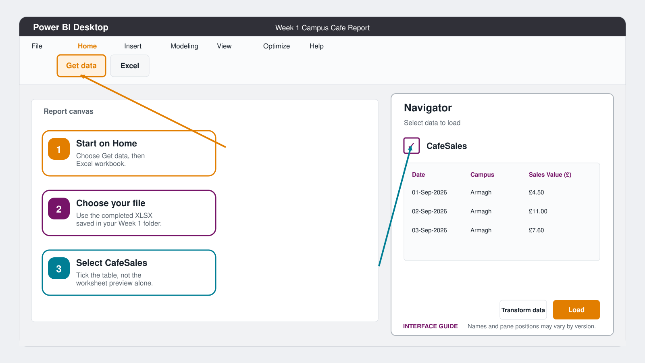
Import the table named CafeSales, not a loose worksheet range.
1 Connect
Choose Home, Get data, Excel workbook. Select Surname_Firstname_Week1_Campus_Cafe.xlsx.
2 Choose the table
In Navigator, tick CafeSales. Preview the columns and choose Load.
3 Find the work areas
Locate the report canvas, the Visualizations pane, and the Data pane. The Data pane may be called Fields in some versions.
4 Save now
Save the report as Surname_Firstname_Week1_Campus_Cafe.pbix before building visuals.

Import checkpoint
□ CafeSales appears in the Data or Fields pane.
□ Sales Value has a number or currency icon, not a text icon.
□ The Power BI file has been saved in your Week 1 folder.

Activity 5 Build and explain the report
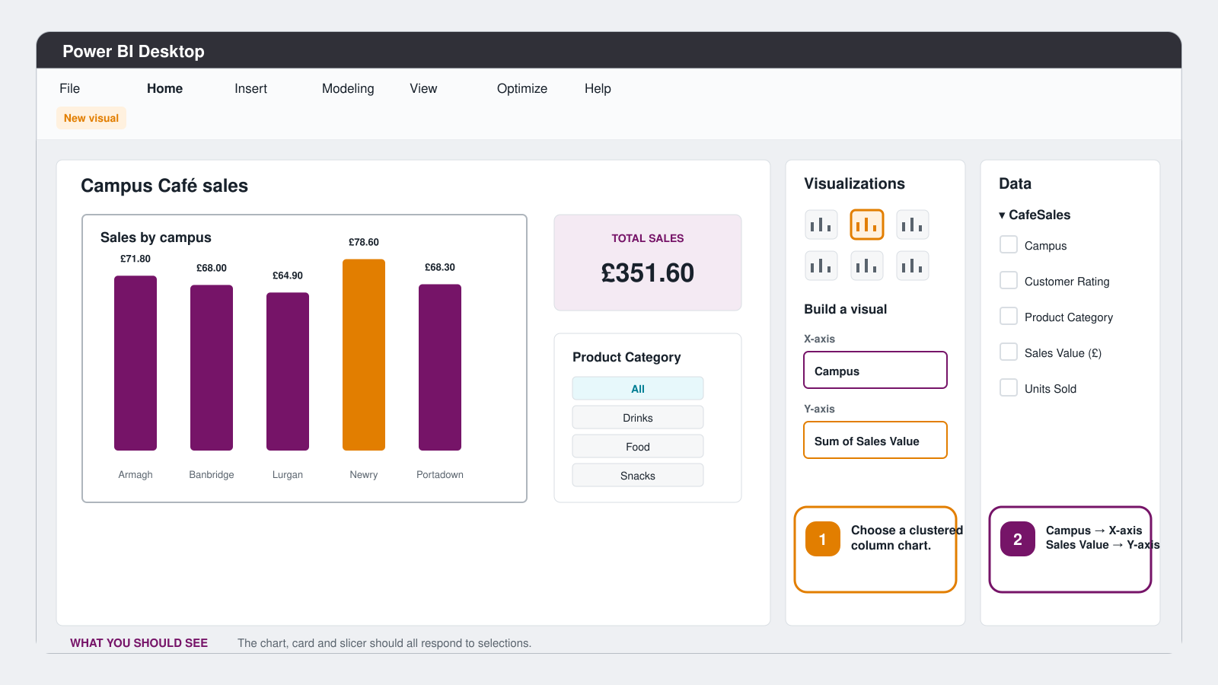
Target report: Campus on the X-axis, Sum of Sales Value on the Y-axis, a total-sales card, and a category slicer.
Build Column chart: Campus on X-axis and Sum of Sales Value on Y-axis. Card: Sum of Sales Value. Slicer: Product Category. Test that the slicer changes the chart and card.
Important check If the card shows 50, Power BI is counting rows. Open the Sales Value field menu and change Count to Sum; the card should show £351.60.

Write your conclusion
Finding What does the report show

Possible action What could the cafe team consider

Limitation What can this small dataset not prove

Extra field What else would improve the staffing decision

Activity 6 Review and submit
Answer the five questions without looking back first. Your score is useful feedback, not a judgement.
1. A card shows 50 instead of £351.60. What should you change?
A Change Sum to Count B Change Count to Sum C Delete the table
2. For Sales by campus, which field belongs on the X-axis?
A Campus B Sales Value C Transaction ID
3. Why should Sales Value use Sum in the card?
A It adds the money values B It counts rows C It sorts the table
4. Which extra data would best support a staffing decision?
A Transaction time and staff hours B Font colour C Report page size
5. The report summarises past sales from 1 to 10 September. What type of analysis is this?
A Descriptive B Predictive C Prescriptive
Record your answers as five letters

Submit in Teams
□ Surname_Firstname_Week1_Campus_Cafe.xlsx with all four Check My Work cells showing PASS.
□ Surname_Firstname_Week1_Campus_Cafe.pbix with the three required visuals.
□ Your completed PDF, if your tutor asks for it, or a screenshot of the conclusion and quiz responses.

Optional stretch
- Add a second chart showing Sales Value by Product and explain what it adds.
- Create a Total Sales measure with SUM(CafeSales[Sales Value (£)]).
- Write one diagnostic question and name the extra data needed to answer it.

